INTERNATIONAL MEDICAL EDUCATION FUNDRAISING
Contact

Christine DeBastiani
Coordinator, College of Medicine Office of Alumni Affairs
cdebastiani@ufl.edu
352-273-5867

GLOBAL HEALTH WEBSITE

Our Global Health website has documents, information on trips, elective and upcoming events. It provides access to needed forms such as (https://globalhealth.med.ufl.edu):
- Fundraiser approval form & Event Planning Sheet (These should be submitted together 6 or more weeks prior to proposed event)
- Gift-in-Kind Donation record (for item donations)
- Sample ASK letters for mailings and to use verbiage for email ASKS
- Global Health Information Sheet for Marketing (Please furnish more up-to-date information to me if you would like it updated) -- great to include in solicitation letters or face-to-face asks
- Silent auction bid sheet
- UF Tax Exempt form
- Online Store tear-off (as seen on Online Store poster) -- great to include in solicitation letters
- Online Store flier www.drgator.ufl.edu/onlinestore -- great to include in solicitation letters

Please visit the website for successful fundraisers such as The Curry’s concert, The online store, highlights from Alumni Weekend & the Silent Auction.

SET YOURSELF UP FOR SUCCESS: MAKE A PLAN & WORK THE PLAN

- START NOW – LESS WORK LATER
- WORK WITH WHAT YOU CAN CONTROL IN THE PRESENT
- PLAN FOR THE FUTURE
- WORK SMARTER, NOT HARDER
- SET CLEAR, REALISTIC, MANAGEABLE GOALS & DEADLINES
- BE A LEADER – DELEGATE, FOLLOW-UP, ACCOUNTABILITY
- PLAN FOR EFFECTIVE MEETINGS & APPOINTMENTS – BE PREPARED, BE PROFESSIONAL
- WORK TOGETHER & BUILD IN APPROPRIATE PREPARATION TIME
- COMMUNICATE, COMMUNICATE, COMMUNICATE

FUNDRAISING STRATEGY – LEAST EFFORT, LARGEST PROFIT

WHO
- COM Alumni – 14,000 +/-
- Students – 55,000 +/-
- Gator Sports Fans – 90,000 +/-
- Residents & Fellows – 800 +/-
- Faculty
- UF & Shands Employees -- 20,000 +/-
- Family & Friends – Unlimited
- City of Gainesville
HOW
- Alumni Weekend online registration sales
- Alumni Weekend on-site sales, promotion & donations
- DrGator, FL Physician articles (Highlighting Global Health program & ways to support)
- Development Newsletter – The Dose
- Flyers, Posters, Word of Mouth
- Email, Facebook, Instagram, Snapchat
- Letters
- Organizations who match employee donations
- The Alligator & Gainesville Sun Newspapers
- WUFT (NPR) & GHQ Radio
- Event Venue Website/Facebook Page
- Dr. Duff & Student Affairs Office
- UF COM Communications team
- GH, COM, PA Alumni Affairs website
- City of Gainesville Website, Visit Gainesville

WHAT
2018-19 FUNDRAISING INITIATIVES

Online Store (All Year)
- http://drgator.ufl.edu/onlinestore
- Development Office Alumni Visit Packet Flier
- Alumni Weekend emails, mailers & posters
- MD, HS, PA Orientation & Graduation

Auction/Talent Show – Spring
- Items to auction
- Analyze what sold best & for the highest amount of $ (DO MORE OF THAT, Marcus Threadcraft)
- 2017 = $2216
- 2018 = $4188
- Revenue difference of $1972 ($1500 1-week time share, UF COM Communications & Student Affairs)

Letter & Email Campaign (Template Letters available – see below. Emails to be based upon verbiage in letters)
- Friends
- Family
- Matching gifts (organizations and corporations)
- Local businesses (In Gainesville & from your Home Town)
- Think about including the online store fliers and/or tear-offs in your letters

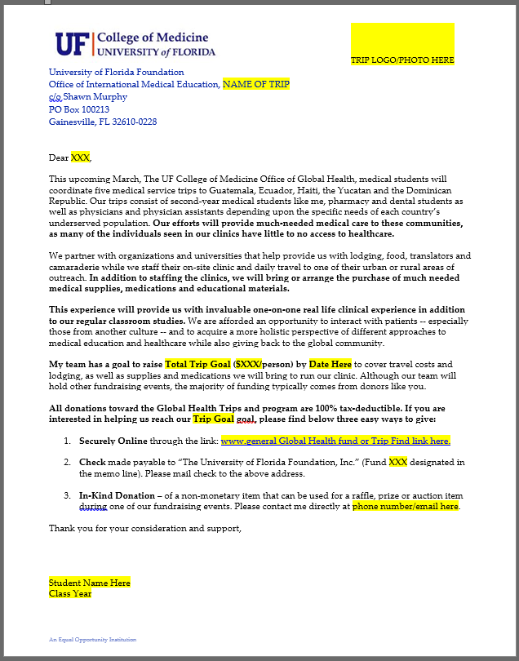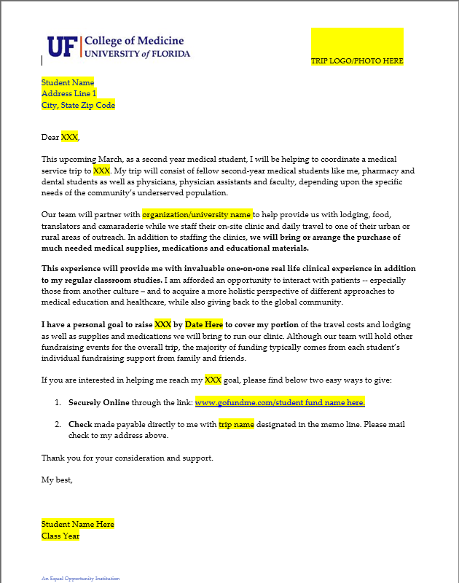

Fall Concert or other Fundraiser (Virtual 5K – Get T-shirts donated)
- Marketing (Facebook, word of Mouth, T-Shirts, Radio (NPR), Email, Posters, Facebook, Newspapers, Venue Website, Apps)
- Ticket/registration revenue
- Donations

Alumni Weekend – NOVEMBER 9 & 10
- Item(s) sold through online registration (pick-up Alumni Weekend)
- Items sold on-site during Alumni Weekend from International Medical Education table
- On-site Raffle (Bags & Head Coach signed Helmet)
- We currently have 51 ($815.49) clear cross-body bags available for sale online (AW) and on-site – order totes: 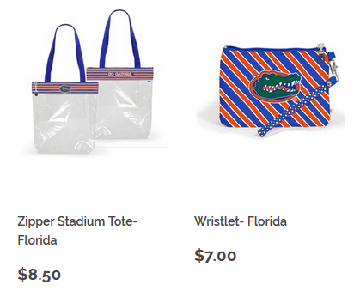

DONATIONS

- Ask for Money for your trip or the entire GH program (IS tax deductible)
- Ask for Money for yourself (NOT tax deductible – that is called a personal gift)
  - Monetary donations to a trip or GH can be made via web link, check, cash
- Ask for In-Kind Donations (Prizes, Baskets, Auction Items, T-Shirts, Items for Pandora Boxes) – Tax deductible
- Remember that someone who gives a donation to the program/a trip may work for a company who matches that employee’s donation which will double the donation (ex. Apple) – contact Christine for more information.

- Don’t be Shy – you have nothing to lose (People will say NO and they will say YES – That’s Life)
- Make as many donation “Asks” as possible
- Thank them whether they give or not and be sure to send TY cards to those who do give (Prep them for next year’s student asks)
- Work as a TEAM - DO NOT let the work fall on one person – do your part
- Use the Global Health “What We Do” flier
- GET STARTED NOW (summer – here in Gainesville and/or in your home town)
- Be sure to record all donation information on corresponding form & submit to Christine so that donors receive tax donation letters from The UF Foundation

2017-2018 FOGH REVENUE
Date | Event | Description | Gift-In-Kind | Donation | Revenue
2/18/2017 | Talent Show/Auction | Auction Proceeds |  |  | 2,096.10
2/18/2017 | Talent Show/Auction | Auction Donations |  | 120.00
5/1/2017 | Alumni Affairs Annual Contribution | Mission Trip ODAA Budget (MCC) |  |  | 5600
9/16/2017 | AW | On-Site Bag/Shirt Sales |  |  | 363.85
3/1-9/6/2017 | AW | On-Line Bag Sales |  |  | 963.47
9/16/2017 | AW | Raffle Donations |  |  | 867
 | Fall Benefit Concert - The Currys | Drew Sarka, MD - Gift In Kind Painting | 1400 |  | 250
 | Fall Benefit Concert - T-Shirts (50) | American Business Solutions | 412.5
 | Fall Benefit Concert - The Currys | Heartwood Ticket Revenue
 | Fall Benefit Concert - The Currys | Other Benefit Concert Revenue |  |  | 798
 |  |  | 1812.50 | 120.00 | 11,058.42

2018-2019 FOGH REVENUE
Date | Event | Description | Gift-In-Kind | Revenue | Means Paid | Fund
 | Talent Show/Auction | Auction Proceeds |  | 4,188.00
 | Alumni Affairs Annual Contribution | Mission Trip ODAA Budget (MCC) |  | 3500
 | 1st Quarter | Online Store Sales Proceeds |  | 553.60
 | 2nd Quarter | Online Store Sales Proceeds |  | 273.10
 | 3rd Quarter | Online Store Sales Proceeds
 | 4th Quarter | Online Store Sales Proceeds
 | AW-GH Table | Global Health Donations
 | AW | On-Site Bag/Shirt Sales
 | AW | On-Line Bag Sales |  | 15.99
 | AW | Raffle Donations
 | Fall Fundraiser - T-Shirts (50) | American Business Solutions
 | Fall Fundraiser ($35 x 50) | Revenue - Entrance
 | Fall Fundraiser/Spring Silent Auction ($50 x 50) | Pandora Box or other
 | 10% Food Sales | Food Truck Vendor if applic.
 |  |  |  | 8,530.69

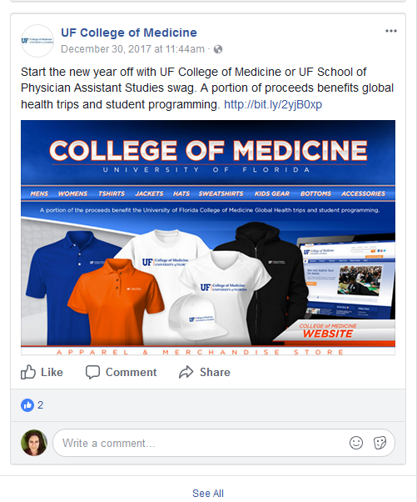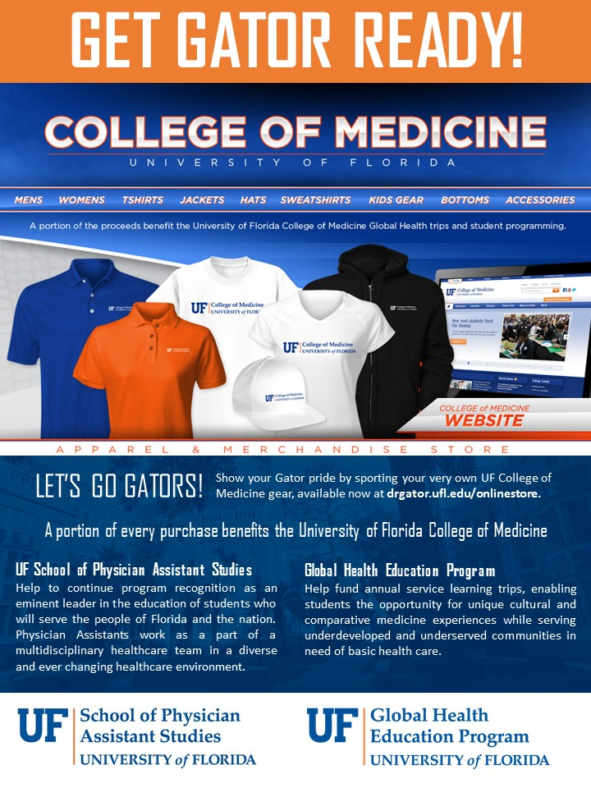
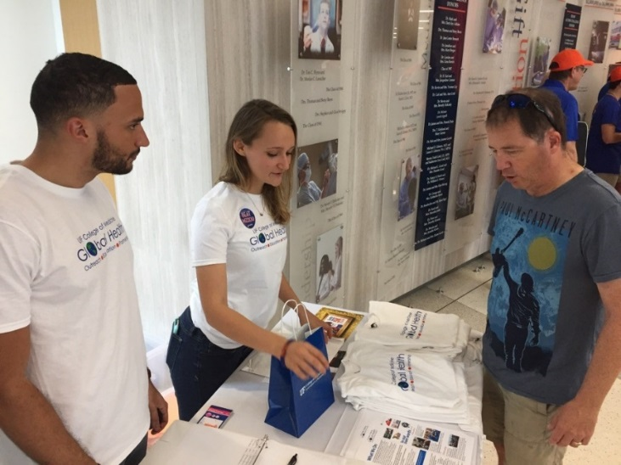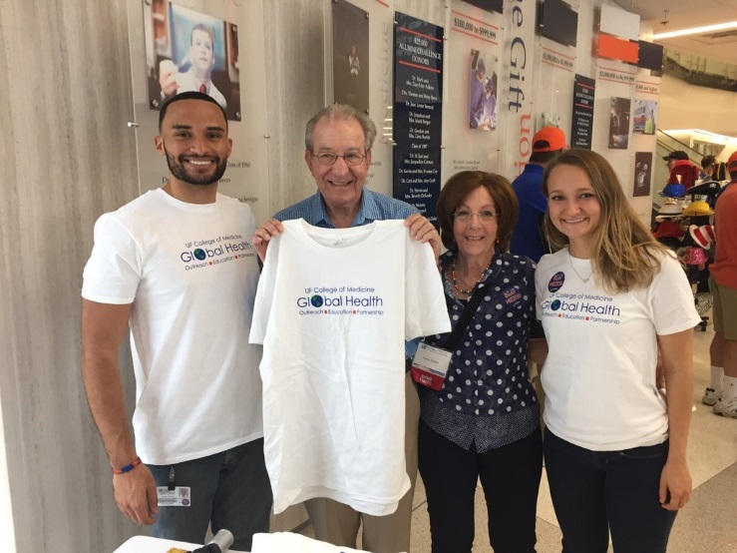
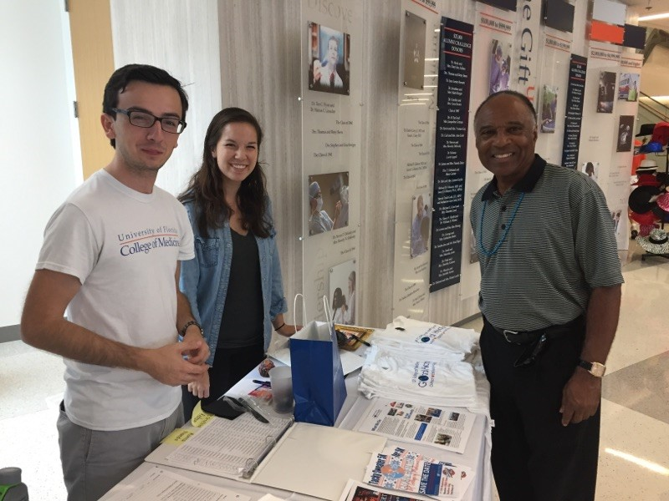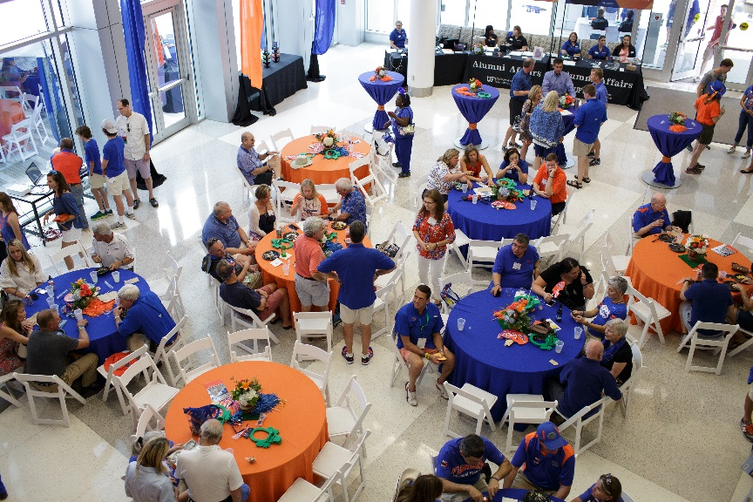
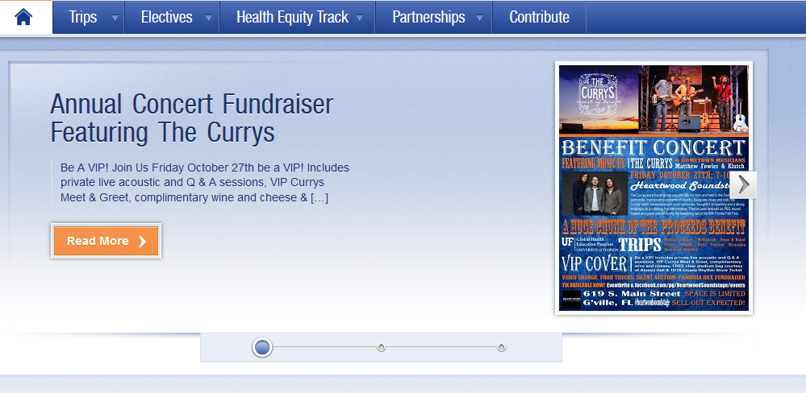

The Currys Benefit Concert Fundraiser 2016
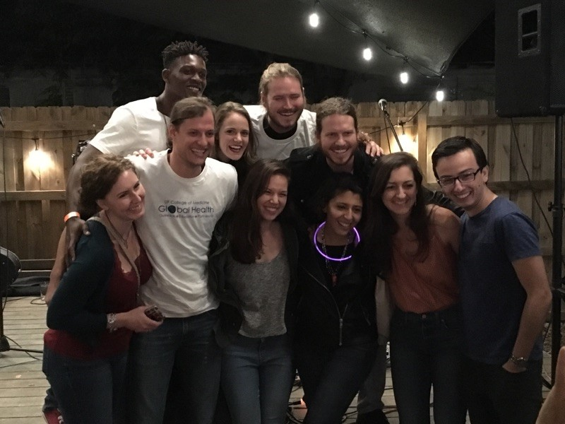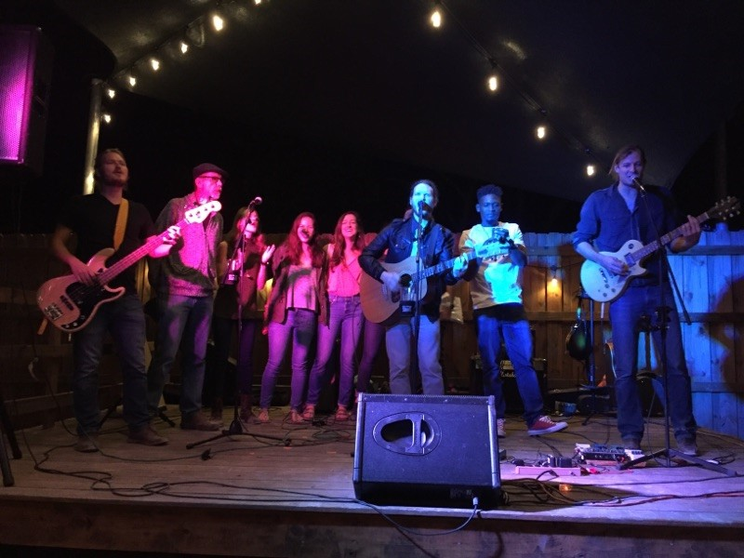
The Currys Benefit Concert Fundraiser 2017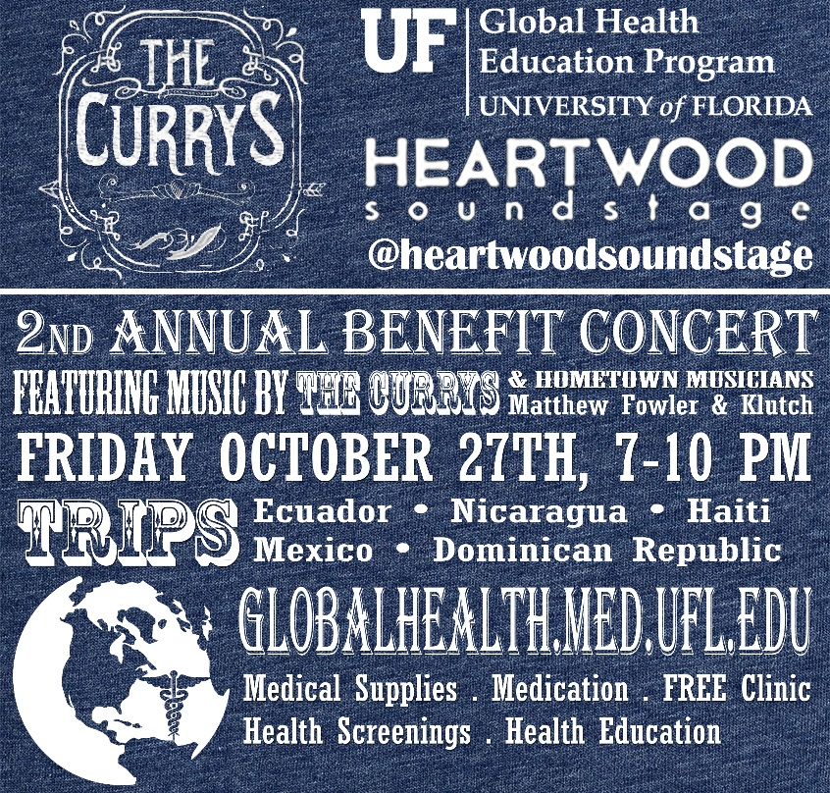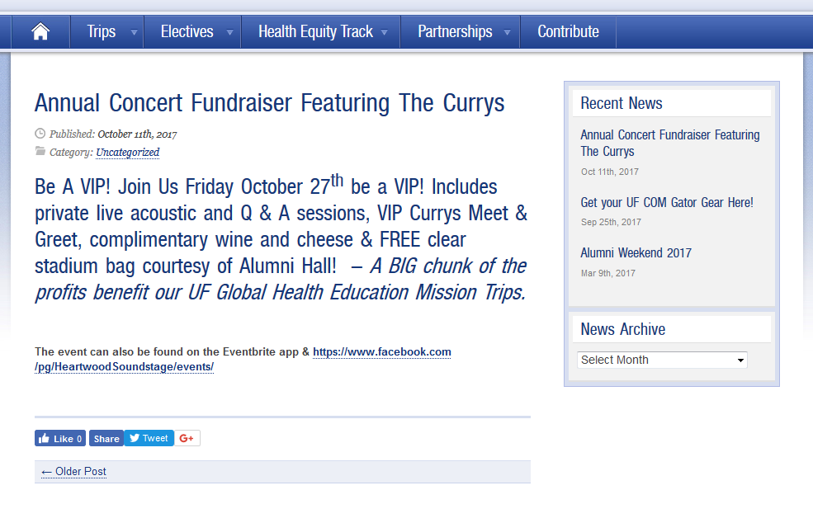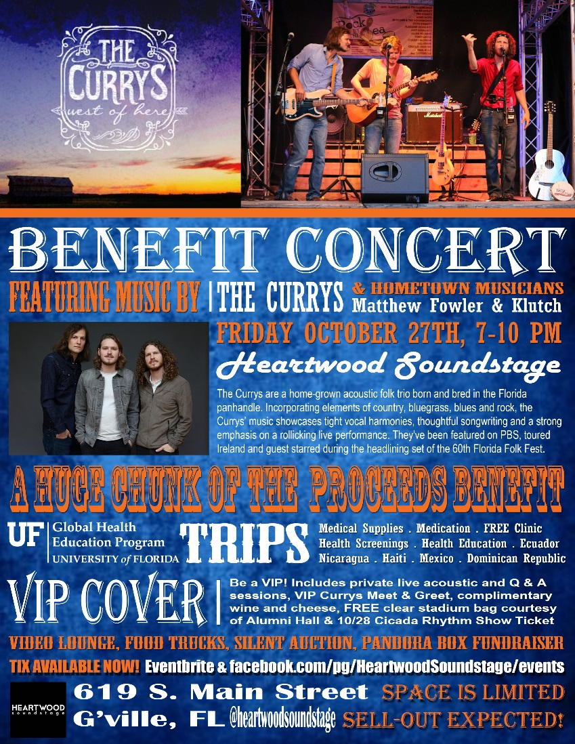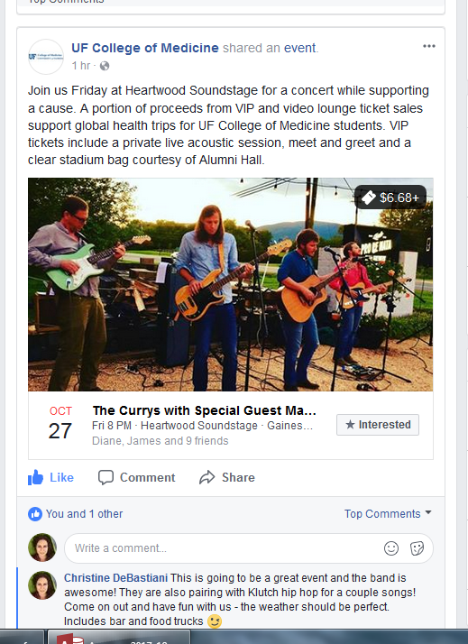
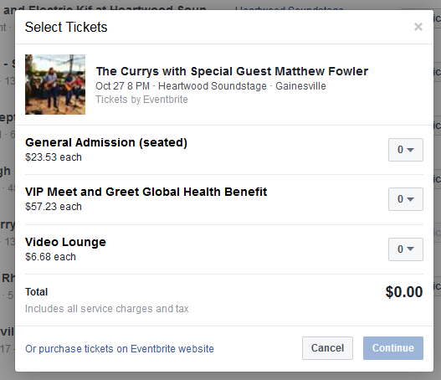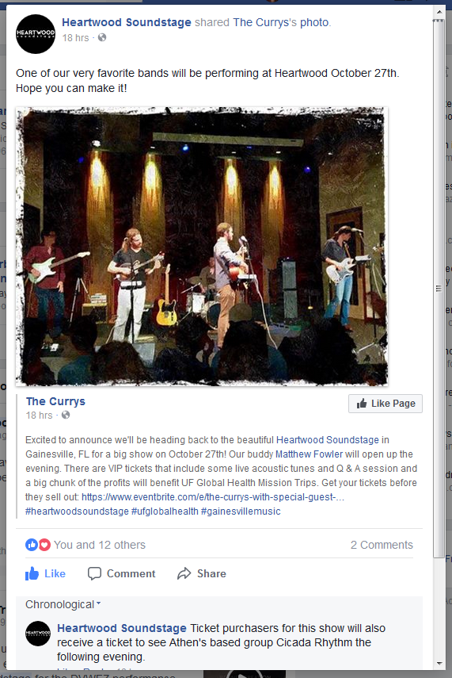

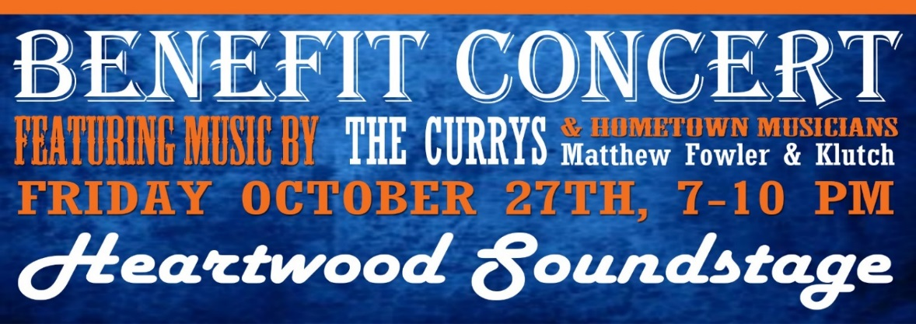

PRESS RELEASE

UF Global Health Education Partners with Heartwood Soundstage and The Currys for 2nd Annual Mission Trip Benefit Concert

Gainesville, Florida
October 27, 2017

VIP Private Live Acoustic with Q & A Session: 7-8 pm, $25 online ($50 for VIP & Main Event)
Main Event: 8-10 pm ($20 online or $25 at the door)

Heartwood Soundstage
619 S. Main Street
Gainesville, FL
2nd Annual Fundraiser features music by the home-grown acoustic folk trio, The Currys and local guests, Matt Fowler & hip hop artist, Klutch. First and second year medical students are raising money to provide Medical Supplies, Medication, a FREE Clinic, Health Screenings, and Health Education to underserved communities during their spring break trips to Ecuador, Nicaragua, Haiti, Mexico and the Dominican Republic. The UF Global Health Education program enables medical students the opportunity for unique cultural and comparative medicine experiences while serving underdeveloped and underserved communities in need of basic health care.
The Currys are a home-grown acoustic folk trio born and bred in the Florida panhandle. Incorporating elements of country, bluegrass, blues and rock, their music showcases tight vocal harmonies, thoughtful songwriting and a strong emphasis on a rollicking live performance. They've been featured on PBS, toured Ireland and guest starred during the headlining set of the 60th Florida Folk Fest.
Be a VIP! Includes private live acoustic and Q & A sessions as well as The Currys Meet & Greet, complimentary wine and cheese, FREE clear stadium bag courtesy of Alumni Hall & FREE Saturday Cicada Rhythm Concert Ticket. WUFT’s very own Glenn Richards will be hosting the Q&A session.
Tickets Available Now at Eventbrite or visit Heartwood’s Facebook page
Contact:
Christine M. DeBastiani
Program Coordinator

RADIO WUFT FM 89.1 NPR for 2017 promotion

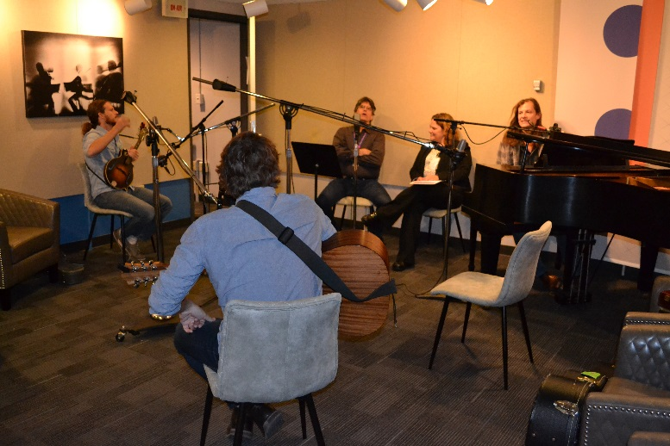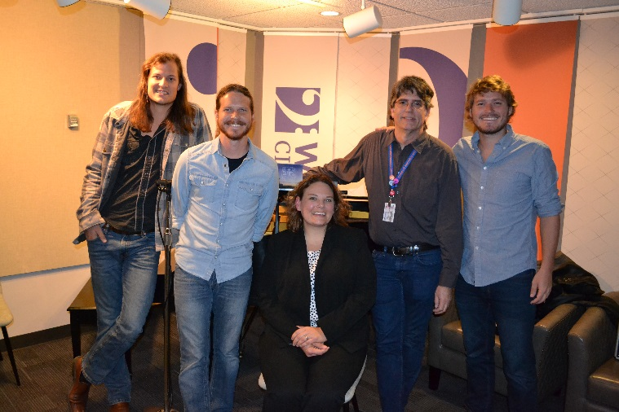

Heartwood 2017
